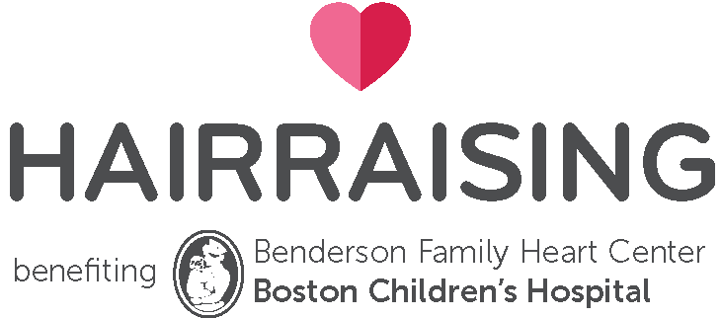

HAIRraising Social Media Salon Outreach

Accounts to like and tag:

HAIRraising
Facebook @HAIRraising
Instagram @hairraising_bch
Boston Children’s Hospital
Facebook @BostonChildrensHospital
Twitter at @BostonChildrens
Instagram @bostonchildrens
Benderson Family Heart Center
Facebook @heartcenter

Please also use #HAIRraising and #HAIRraising2023 when posting.

Below are some suggested posts for your own channels. Feel free to customize and add your salon name too! (when first posting please use the official name of “Boston Children’s Hospital” and then “Boston Children’s” after).
Please contact us at Boston Children’s Hospital Trust with questions at HAIRraising@chtrust.org

After you signed up:

- link to Facebook event page https://fb.me/e/2pu9oq8IW
Facebook Event: Please mark yourself as attending or interested in your personal Facebook and your salon’s account, so your friends can see! You will also be able to post any photos of prep or other fun fundraising in the event page.

- We’re participating in HAIRraising for Boston Children’s Hospital on Sunday, April 30th to support Benderson Family Heart Center. Join us on April 30th for our cut-a-thon event or stop in at any time to make a donation.

- share recruitment graphic provided
We are so excited to be participating in HAIRraising 2023! It is a great way to show your support for the local community and get to know your customers! Register your salon today at hairraising.org #HAIRraising #HAIRaising2023

March:

- share a photo of your team participating in a previous HAIRraising event:
#TBT to last year’s HAIRraising Cut-a-thon! We had a great day, but we can’t do it without YOU! Call us today to book your appointment for Sunday, April 30, and tell your friends so they can take advantage of this special offer! #HAIRraising #HAIRraising2023

- insert the donation link in your Instagram bio or link it in your story to direct people there to make a donation: https://secure.childrenshospital.org/site/Donation2?df_id=2420&2420.donation=form1
We’re counting down the days until April 30 and our @HAIRraising for Boston Children’s Hospital Cut-a-thon! Don’t miss out on a fabulous haircut that supports a great cause. There are still appointments available – call now to book one. If you can’t make it, you can still donate by visiting the link in our bio – make sure to indicate our salon in the ‘Salon Name’ field. #HAIRraising #HAIRraising2023

- insert the donation link in your Instagram bio or link it in your story to direct people there to make a donation: https://secure.childrenshospital.org/site/Donation2?df_id=2420&2420.donation=form1
Every haircut helps! On Sunday, April 30, you can get your haircut with us and all proceeds benefit @Boston Children’s Hospital. Make your appointment today! If you can’t make it on Sunday, April 30, you can still support our efforts by making a donation at the link in our bio.
#HAIRraising #HAIRraising2023

April:

- Help us to make this year’s HAIRraising cut-a-thon the most successful yet! You’ll receive a great new haircut from one of our stylists and all proceeds go to the Benderson Family Heart Center @Boston Children’s Hospital. Visit www.hairraising.org for more information and call us to make an appointment today #HAIRraising #HAIRraising2023

- One week before event - insert the donation link in your Instagram bio or link it in your story to direct people there to make a donation: https://secure.childrenshospital.org/site/Donation2?df_id=2420&2420.donation=form1
One week from today, we will be participating in this year’s HAIRraising for Boston Children’s Hospital cut-a-thon! Give us a call to make your appointment today before space runs out! If you can’t make it next Sunday, you can still donate by visiting the link in our bio. #HAIRraising #HAIRraising2023

- Tuesday, April 25 - insert the donation link in your Instagram bio or link it in your story to direct people there to make a donation: https://secure.childrenshospital.org/site/Donation2?df_id=2420&2420.donation=form1
Today is National Hairstylist Appreciation Day! What better way to celebrate by telling your favorite hairstylist you made an appointment with them or donated to HAIRraising for Boston Children’s! Visit our site to make an appointment and the link in our bio to make a donation today.

- Two days before event
We are only two days away from the HAIRraising Cut-a-thon for Boston Children’s Hospital! Call us to make your appointment today and help create more success stories like Sofia https://www.hairraising.org/patients #HAIRraising #HAIRraising2023

- Event day - Sunday, April 30 - [Post a photo of your staff holding one of the HAIRraising signs.]
Today we’re raising money for HAIRraising for Boston Children’s Hospital. 100% of proceeds of today’s event will help kids at Boston Children’s. You can help too! Stop by and get a great new haircut and make sure to tell your friends! Or you can even donate by visiting: www.hairraising.org. #HAIRraising #HAIRraising2023

